Q: WAP to implement the substitution cipher.

Ans:

Source Code:

#include<iostream>

#include<string>

using namespace std;

// function to decrypt cipher

string decrypt(string code, unsigned int key){

for(int c=0;c<code.size();c++){ // itereting every element in cypher

// ignore characters other then alphabets

if(!((code[c]>='a' && code[c]<='z') || (code[c]>='A' && code[c]<='Z'))) continue;

int firstChar= islower(code[c]) ? 'a' : 'A', //checking if the char in capital or not

relativeVal=code[c]-firstChar, // shifting the values of character between 0-25

newVal=relativeVal-key; // shifting values accotding to key

if(newVal<0){ // changing values if they are negative

newVal+=26;

}

code[c]=firstChar + newVal; // changing realative values to original values and storing them

}

return code;

}

// function to encrypt the cipher

string encrypt(string code, unsigned int key){

for(int c=0;c<code.size();c++){ // iterating every element in cypher

//ignore characters other then alphabets

if(!((code[c]>='a' && code[c]<='z') || (code[c]>='A' && code[c]<='Z'))) continue;

int firstChar=islower(code[c]) ? 'a':'A', //checking if the char in capital or not

relativeVal=code[c]-firstChar,// shifting the values of character between 0-25

newVal=(relativeVal+key)%26;// shifting values according to key and mentaining them in range 0-25

code[c] = firstChar + newVal;// changing realative values to original values and storing them

}

return code;

}

int main(){

unsigned int key;

string code,descision;

// taking input for code

cout<<"Enter the code.\t";

getline(cin,code);

//taking input for key

cout<<"Enter the key:\t";

cin>>key;

// giving user choice to Decrypt or Encrypt

cout<<"Enter \"D\" to decrypt and \"E\" to encrypt\n";

cin>>descision;

key%=26; // k must be in range 0-25

if(descision=="D"){ // decrypting code

cout<<decrypt(code,key)<<endl;

}else{ // encrypting code

cout<<encrypt(code,key)<<endl;

}

return 0;

}

Output:

Encryption:

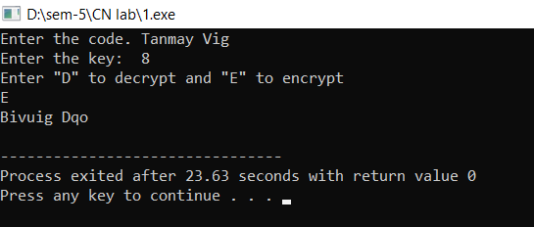

Decryption:

